Assignment 3
3)you have 3 repository in github.all are private reposiory. reposiory1 2026Q1,reposiory2 2026Q2 and reposiory3 2026Q3, all reposiory index.html file present. you have jenkin master server in that apache httpd running.you need to create 3 job for reposiory1,reposiory2 and reposiory3,
when we run 1st job that 2026Q1 repo index.html run, when i run job2 , privious Q1 index.html file delete and q2 index.html file will run and run 3rd job then privious all index.html file qill delete and q3 index.html file will run. dont do override.
Ans_-

I have launch ec2 with jenkin by using below steps
2nd menthod ---- here jenkin home directory is diffrent /root/.jenkins/
install java and tomcat deploy war file.
1)luanch ec2 instance -
yum list java-17-amazon*
2) install java ----- yum install java-17-amazon
3) create folder in /mnt ----- mkdir /mnt/servers
4) install tomcat 10 ---- wget https://dlcdn.apache.org/tomcat/tomcat-10/v10.1.53/bin/apache-tomcat-10.1.53.zip
5)unzip apache-tomcat-10.1.53.zip
6)rm -rf apache-tomcat-10.1.53.zip
7) chmod -R 777 apache-tomcat-10.1.53
8) cd apache-tomcat-10.1.53
9) cd webapps/
10)go to link and select latest Jenkins WAR file --- https://www.jenkins.io/doc/book/installing/war-file/
11)select past release option https://get.jenkins.io/war-stable/
12 select latest --> select jenkins.war file option.
13)wget https://get.jenkins.io/war-stable/latest/jenkins.war
14) cd ../
15) cd bin
16) ./startup.sh
17) cd ../
18) cd logs/
19) tail -100f catalina.out

After that I installed httpd and git on ec2
Yum install httpd
- After on git I created 3 private repository with branch.
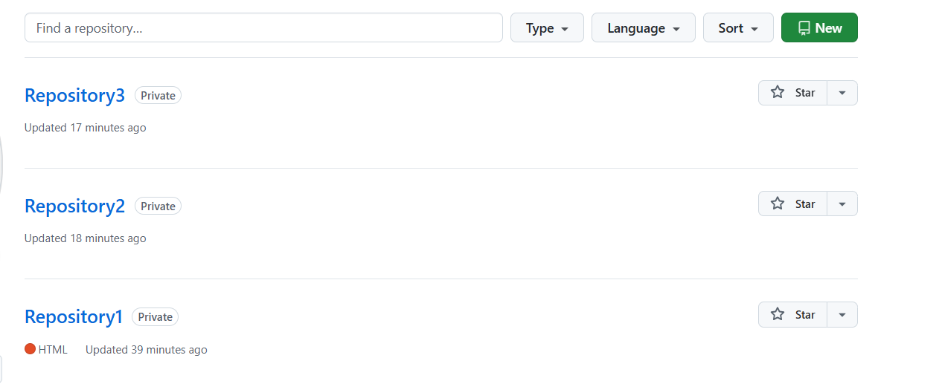
Each repo I created branches like 2026Q1, 2026Q2, 2026Q3
Also created index.html file in each branch
. created Jenkins 3 job with below configuration.
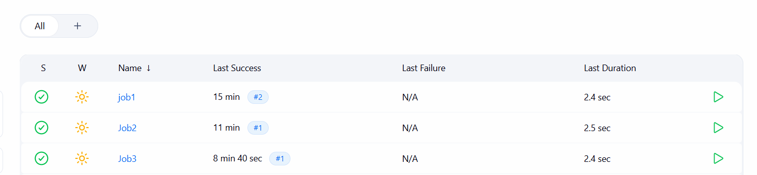
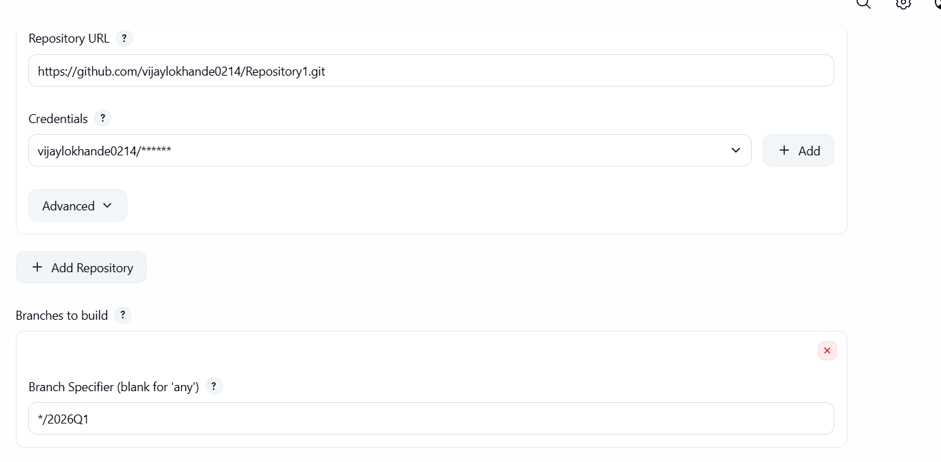
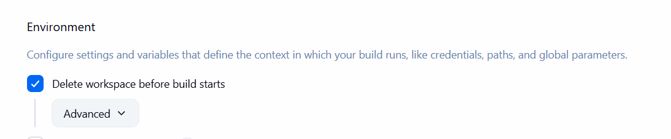
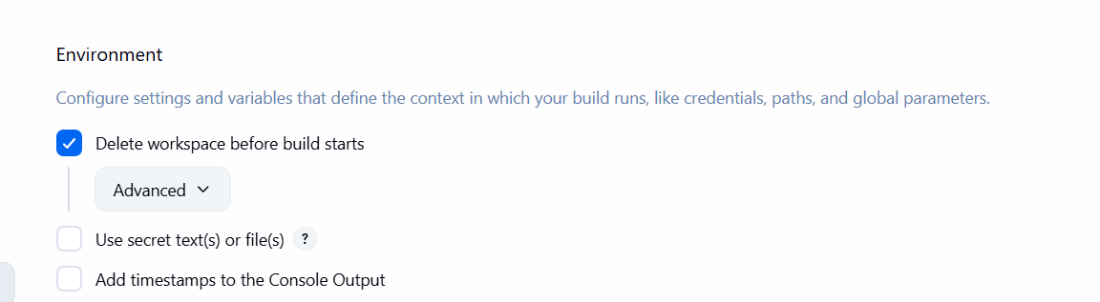
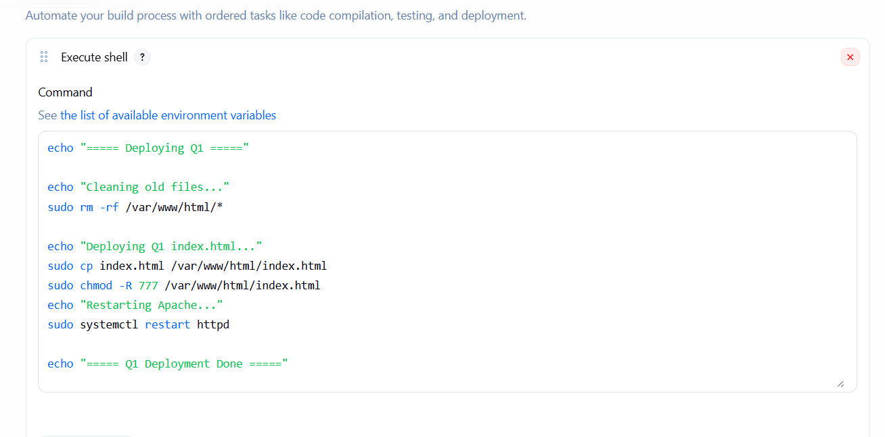

Output
Job 3
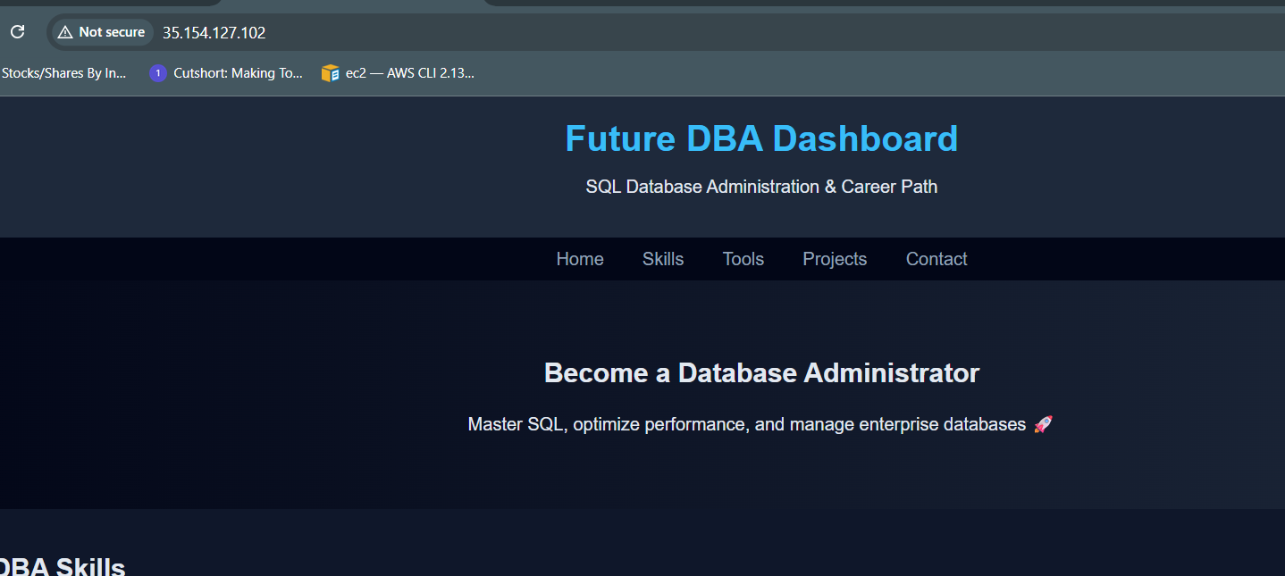
Job2
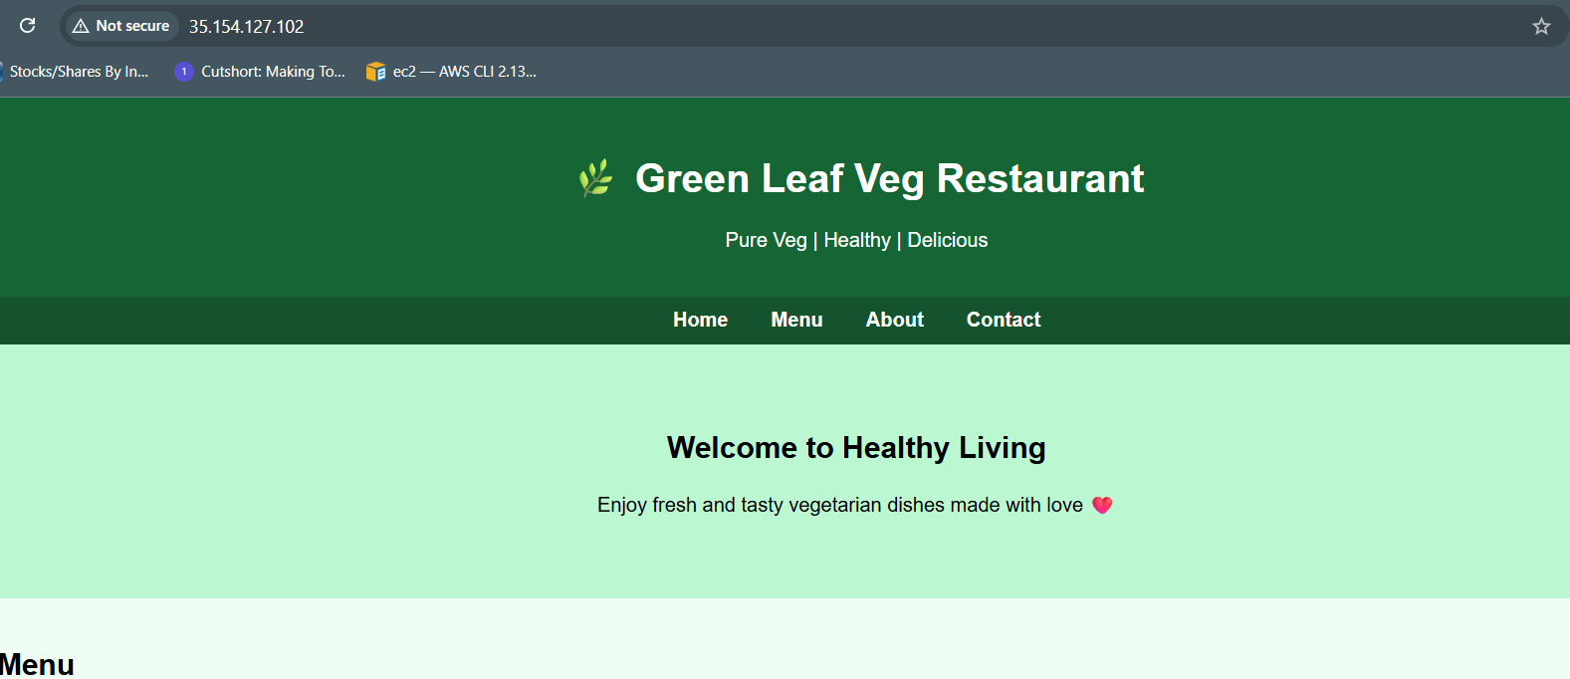
Job1
